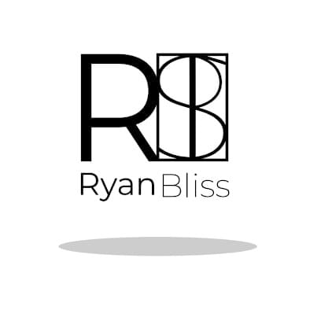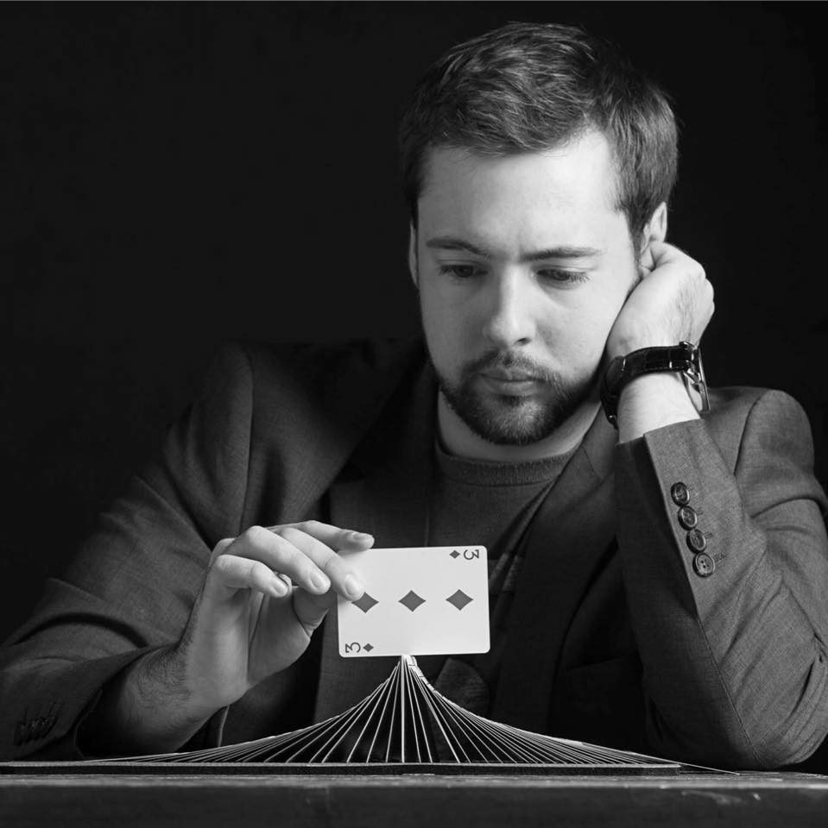

Ryan Bliss is a professional magician from Central New York. Specializing in close-up magic he has had the opportunity to travel the country performing and teaching his material. For this lecture, Ryan will cover a wide array of topics from cards, coins, Okito boxes, mentalism and more, most of which has never been published. The material will range from almost self-working effects to complex sleight of hand feats guaranteed to give you something to work on. In addition, beyond the scope of the standard “trick-explanation” structure, Ryan will dive into theory, psychology and advice for real world performers you will not want to miss.

